**EXPNO 4: CREATE A SNAPSHOT AND CLONING OF A VM AND TEST IT BY**

**LOADING THE PREVIOUS VERSION/CLONED VM**

**DATE:**

**AIM:**

**PROCEDURE:**

**STEP 1: GOTO VMWARE WORKSTATION**

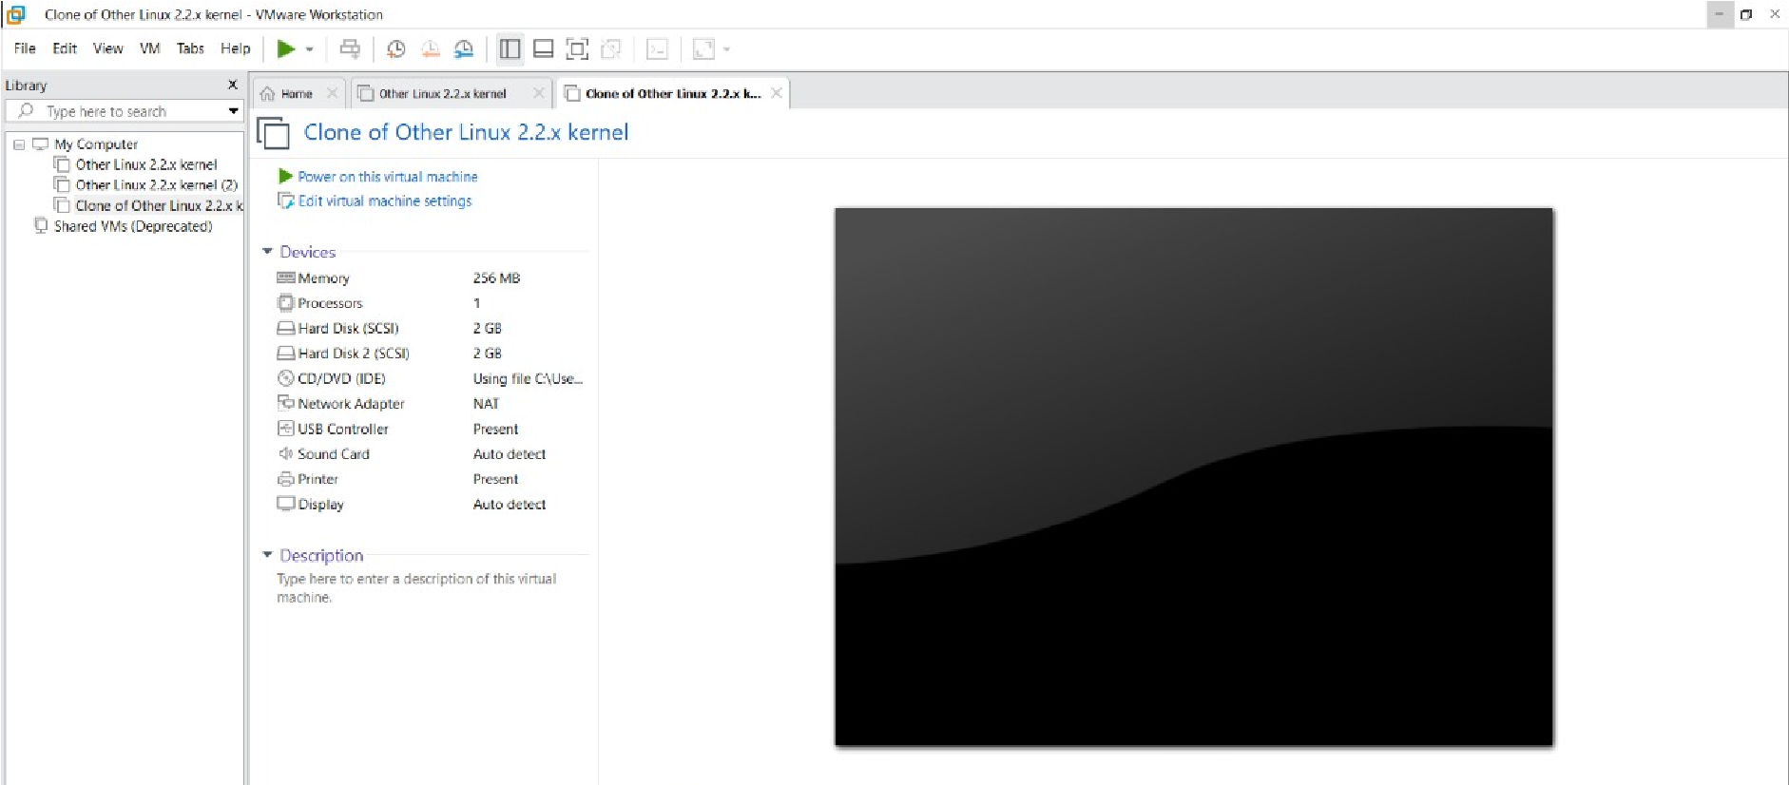

**STEP 2: CREATE FILES ON DESKTOP**

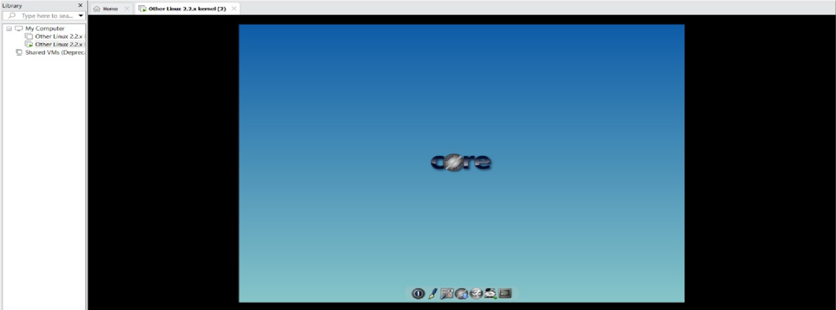

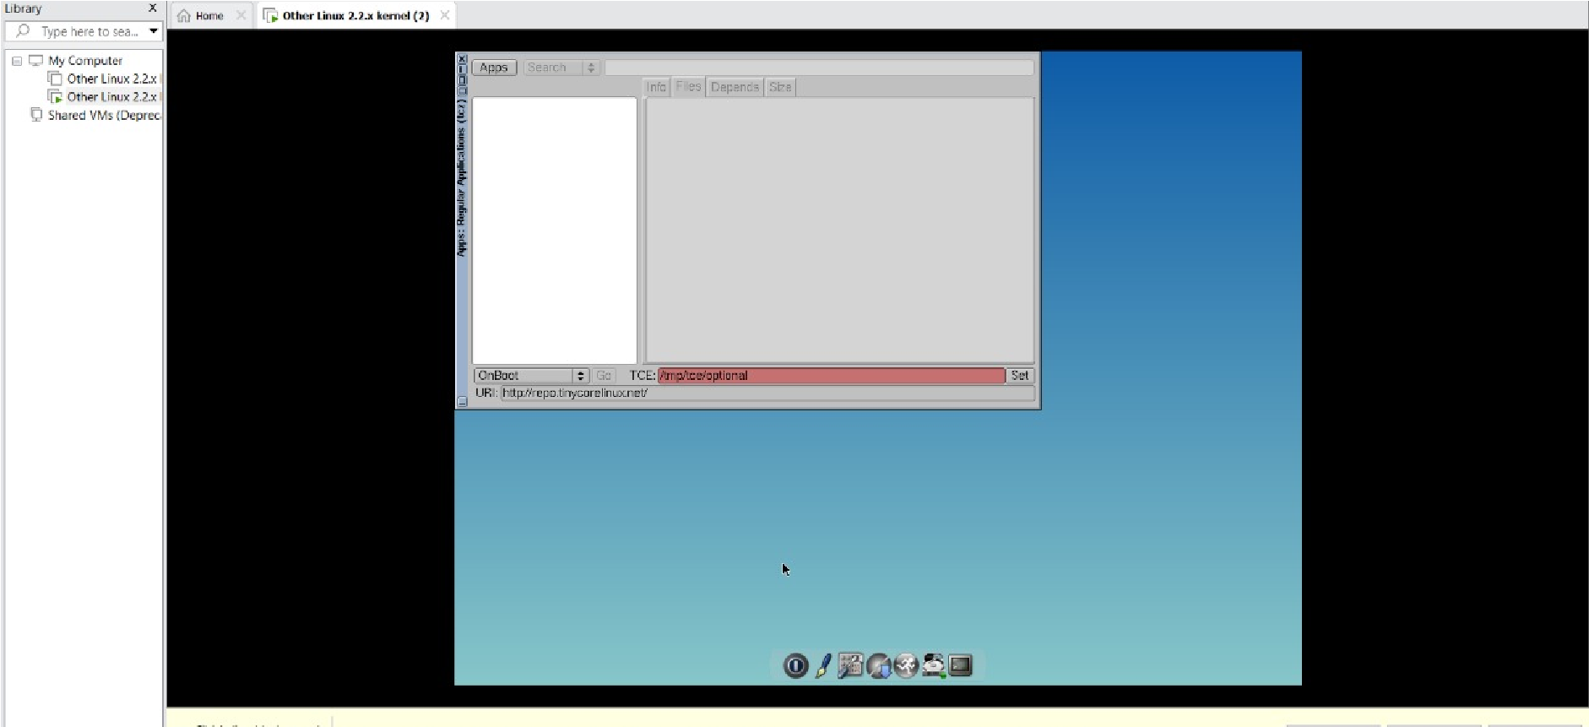

**STEP 2: CLICK ON VM AND SELECTS SNAPSHOT-> TAKE SNAPSHOT.**

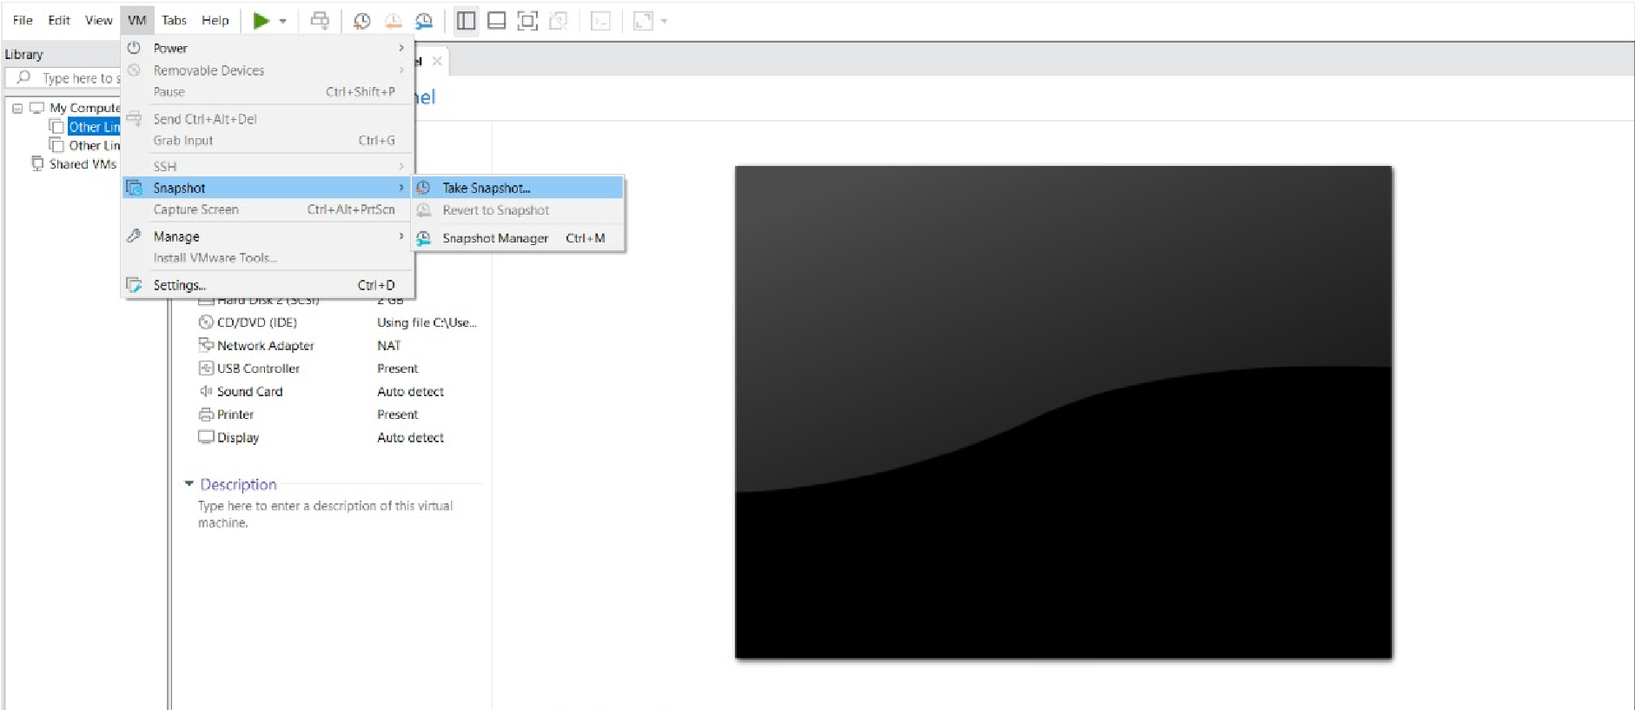

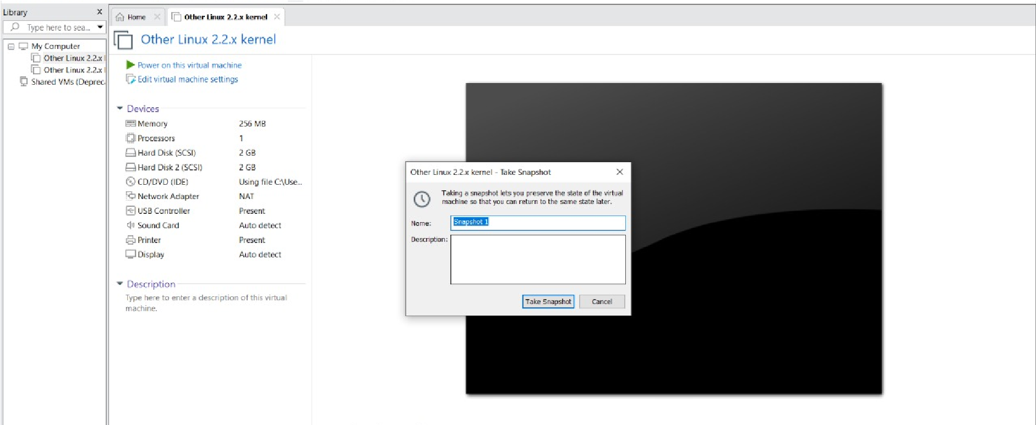

**STEP 4: SNAPSHOT IS BEING DONE**

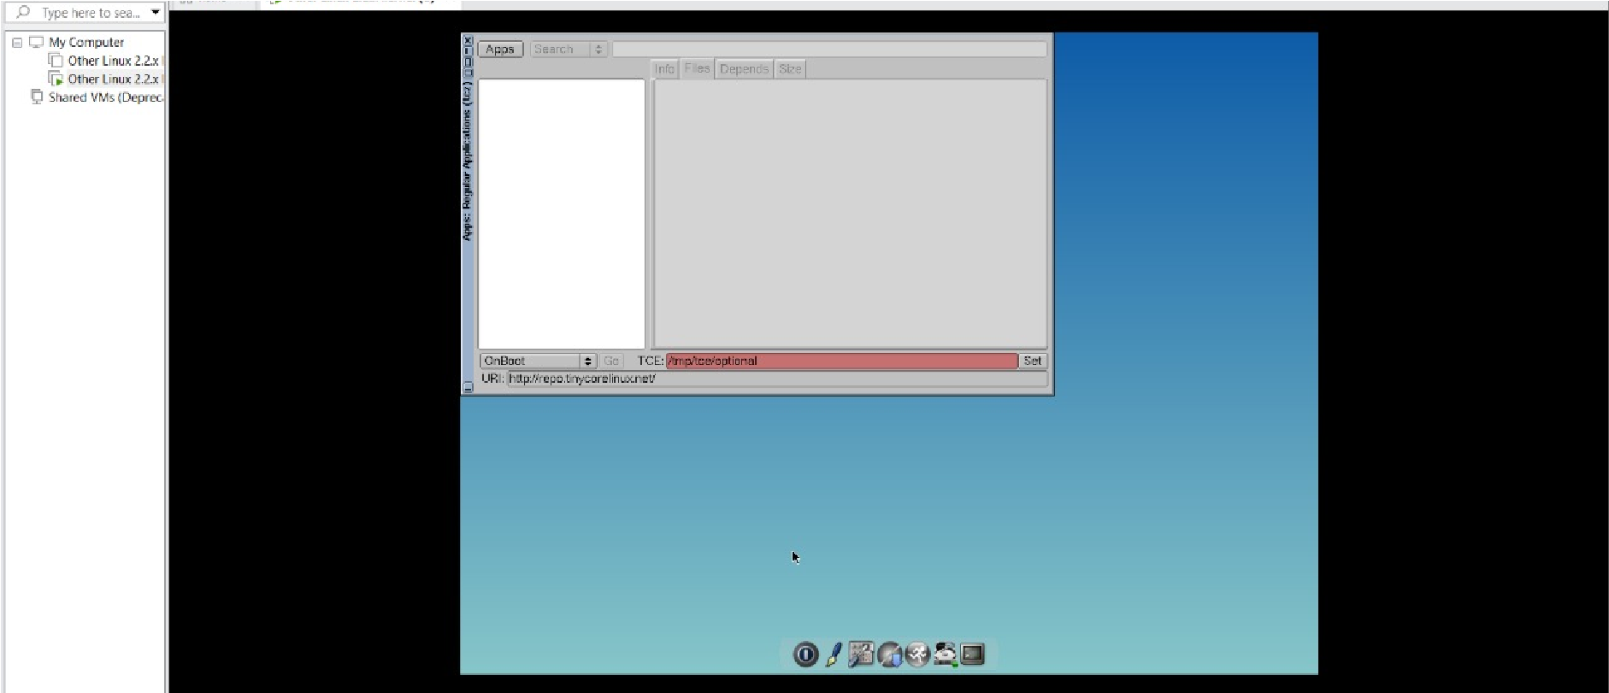

**CLONING OF A VM**

**STEP 1: GO TO VM AND GOTO MANAGE AND CLICK CLONE**

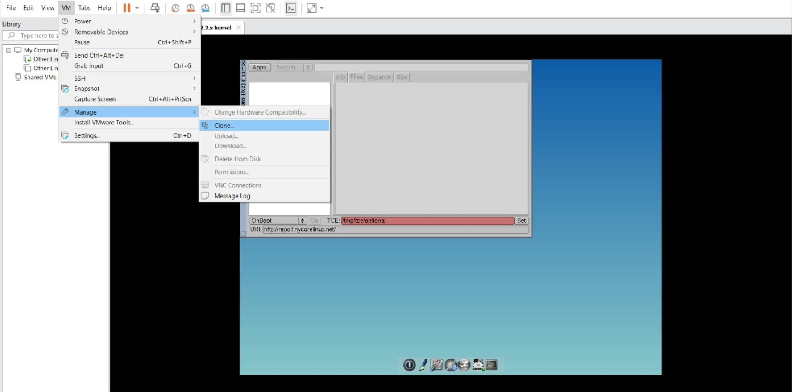

**STEP 2: CLICK CLONE**

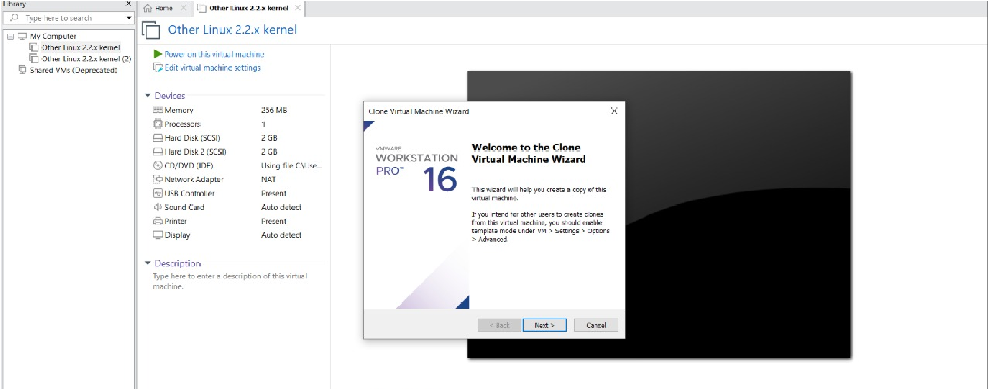

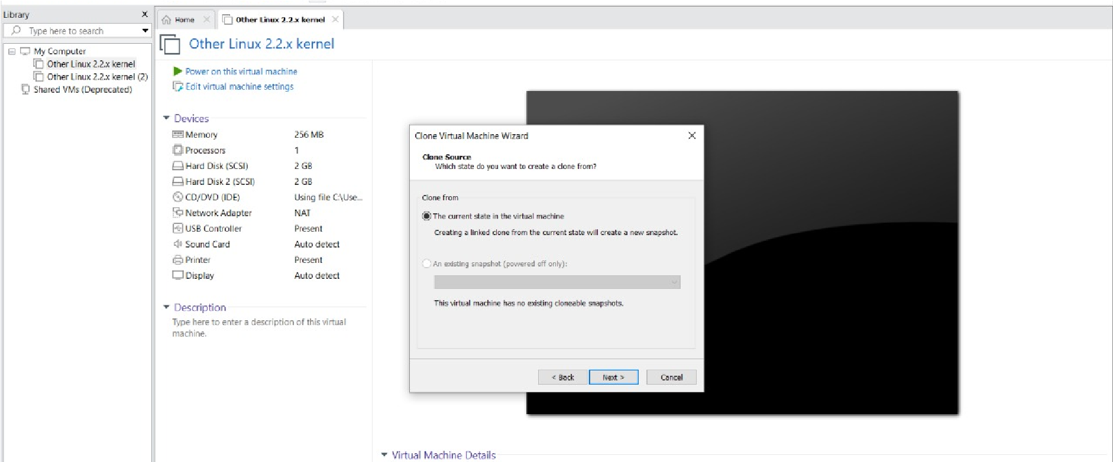

**STEP 3: SELECT THE FULL CLONE**

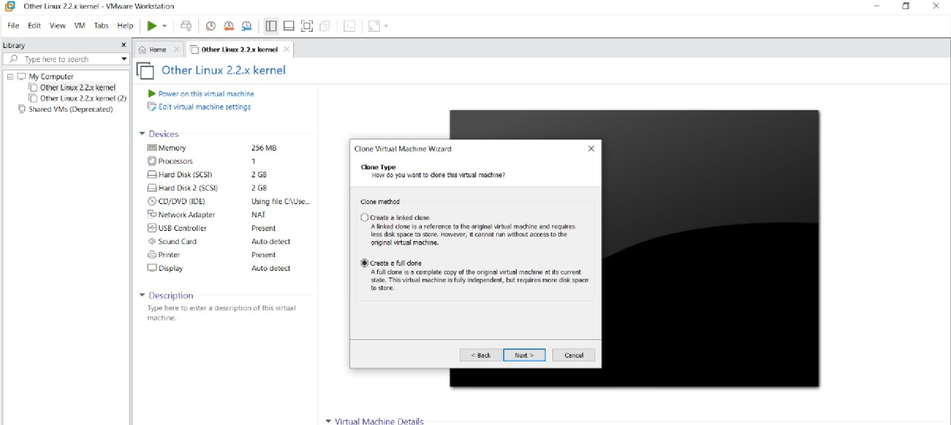

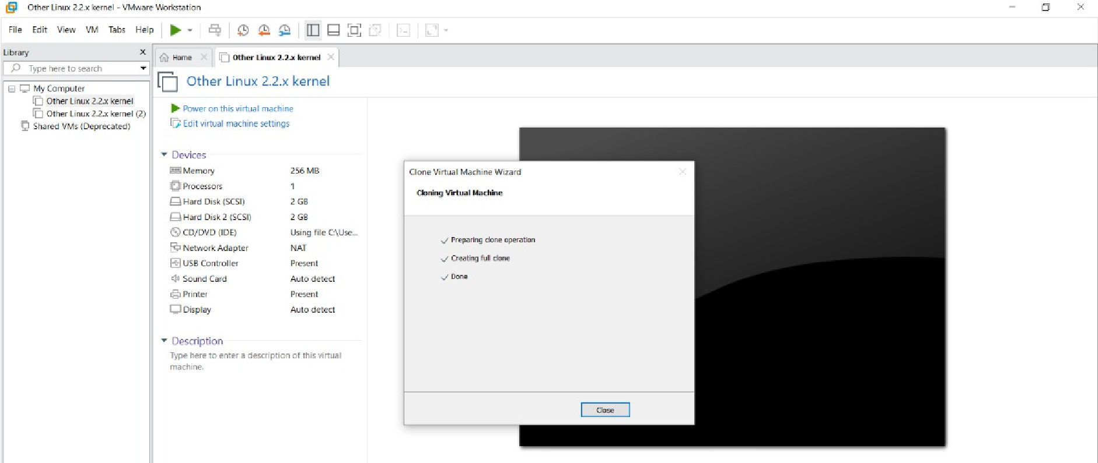

**STEP 4: AFTER CLONE AGAIN OR VM IS OPENED.**





